EXPERIMENT-6

AIM: Write SQL queries to perform JOIN OPERATIONS (i.e. CONDITIONAL JOIN, EQUI JOIN,LEFT OUTER JOIN, RIGHT OUTER JOIN, FULL OUTER JOIN)

CREATING TABLE student :

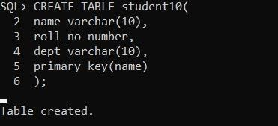

Inserting tables into student table :

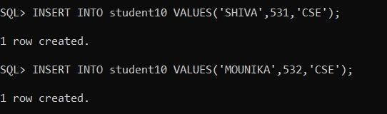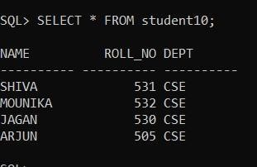

Creating table Library :

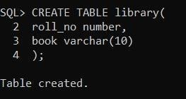

Inserting values into library table :

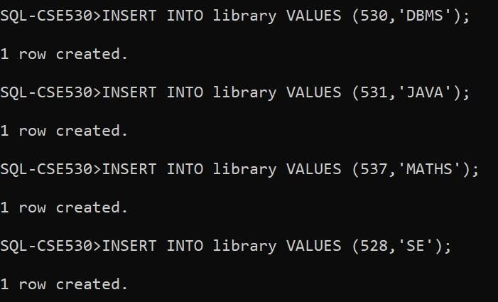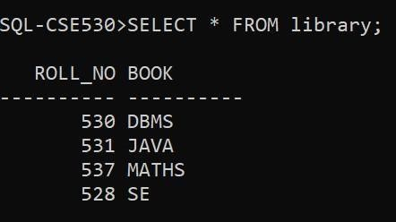

CONDITIONAL JOIN :

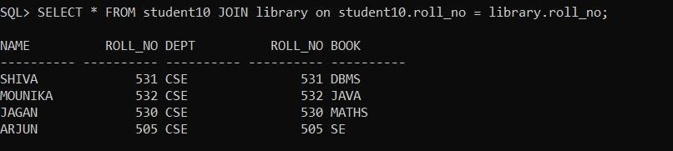

EQUI JOIN :

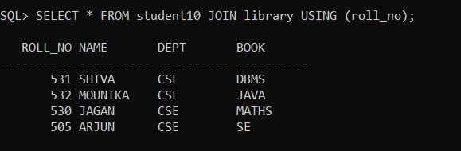

NATURAL LEFT OUTER JOIN :

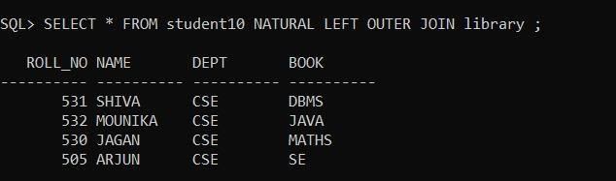

NATURAL RIGHT OUTER JOIN :

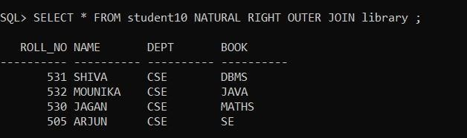

NATURAL FULL OUTER JOIN :

